THE TRAGEDY OF FLIGHT: A COMPREHENSIVE CRASH ANALYSIS

**PROJECT REPORT**

**1.INTRODUCTION**

**1.1 Overview**

The tragedy of flight refers to the devastating consequences of aviation accidents or crashes, which can result in the loss of human lives, injuries, property damage, and economic loss. The analysis of aviation accidents is a critical process that involves investigating the causes and contributing factors that led to the incident and identifying ways to prevent similar accidents from happening in the future. Aviation accidents can occur due to a variety of reasons, including pilot error, mechanical failure, weather conditions, air traffic control errors, and other factors. The investigation process typically involves gathering evidence, analyzing data, conducting interviews with witnesses and experts, and developing a comprehensive report that outlines the finding and recommendations.

**1.2 Purpose**

The purpose of conducting a comprehensive crash analysis of aviation accidents is to identify the factors that contributed to the incident and to develop recommendations for preventing similar accidents from happening in the future. The analysis aims to improve aviation safety by identifying areas of improvement in the aviation industry’s processes, procedures, regulations, and technologies. The tragic consequences of aviation accidents serve as a remainder of the importance of conducting through investigations into these incidents. The purpose of the analysis is to learn from past accidents and to apply the knowledge gained to prevent future accidents. The findings of the analysis are used to inform the development of new safety procedures, regulations, and technologies to improve aviation safety.

**2. PROBLEMS DEFINITIONS & DESIGN THINKING**

**2.1 Empathy map**



**2.2 Brainstorming Map & ideation**

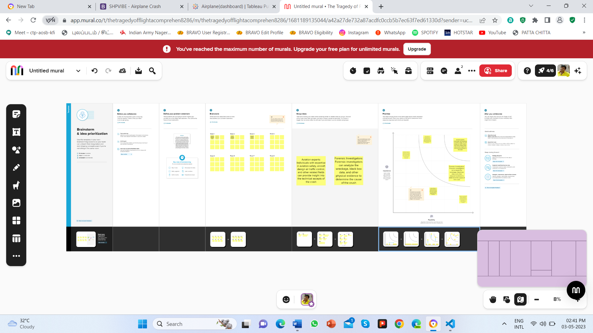

**3.RESULTS**

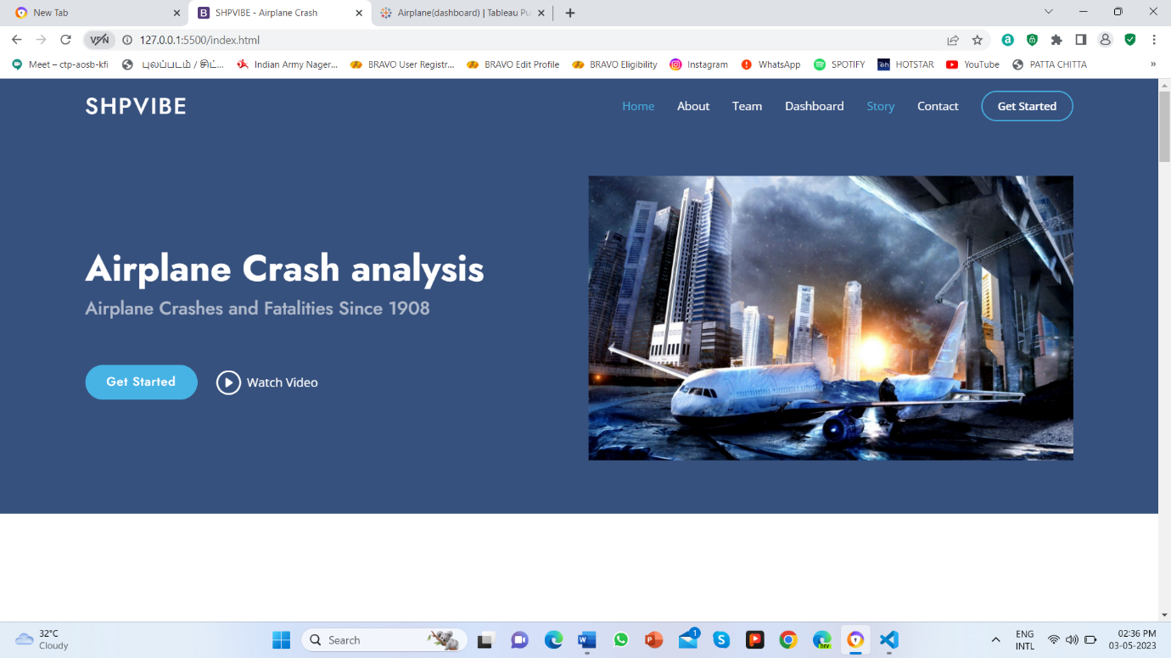

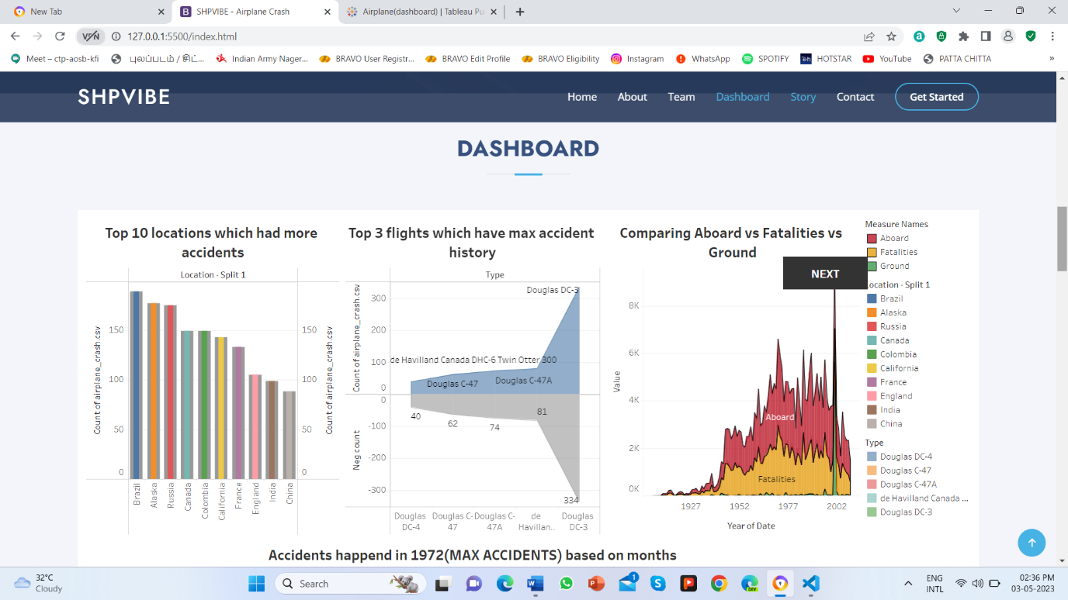

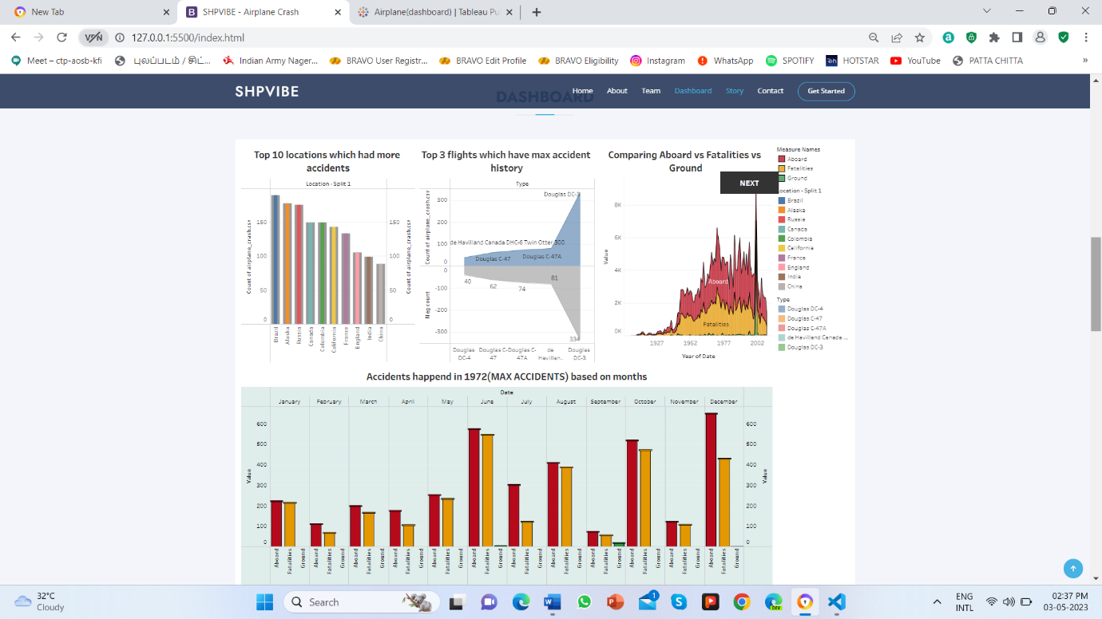

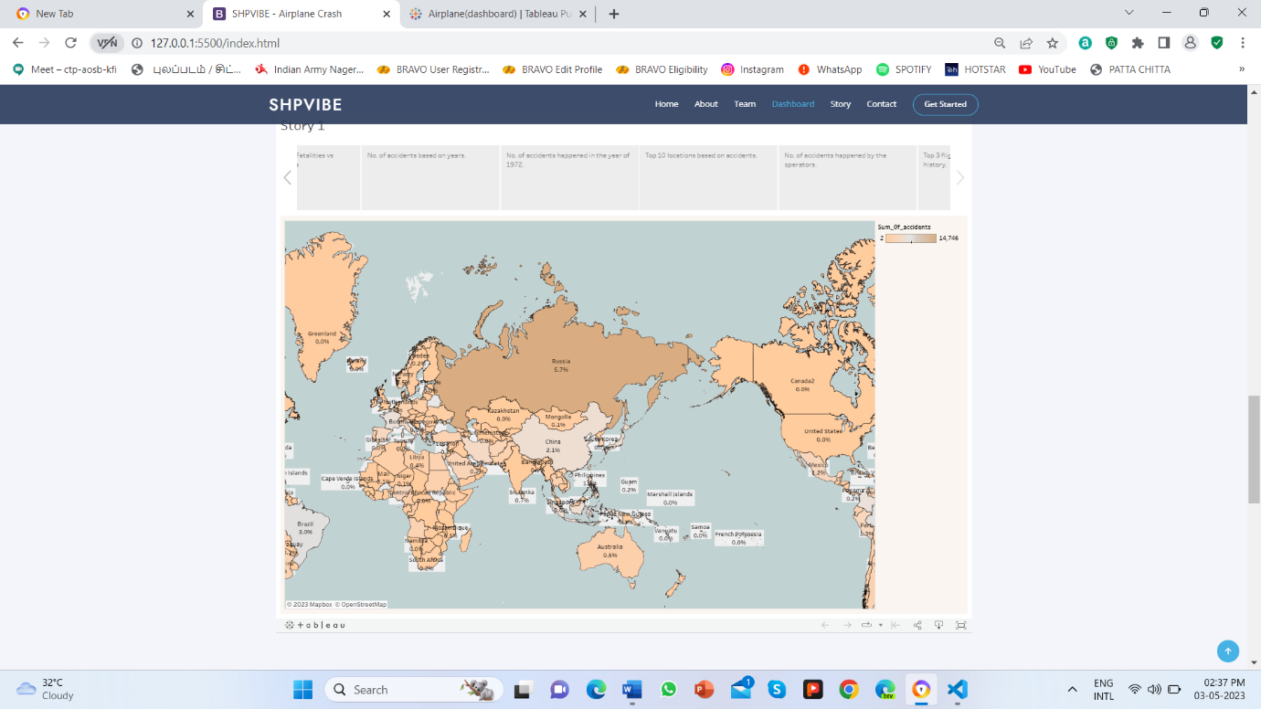

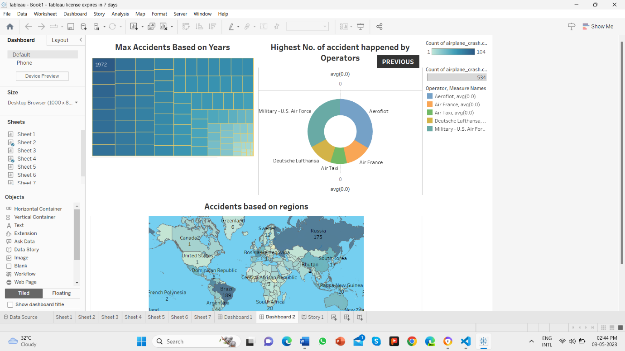



**4 I ADVANTAGES**

* Identifying the cause of the accident: A thorough investigation can help to determine the cause of the accident, including the contributing factors that led to the incident. Understanding the cause of the accident is critical for developing recommendations to prevent similar incidents from happening in the future.
* Improving aviation safety: The finding of the crash analysis can be used to develop new safety procedures, regulations, and technologies to improve aviation safety. This can lead to a reduction in the number of accidents and fatalities, enhancing the overall safety of air travel.
* Providing Closure: The investigation process can provide closure to the families and loved ones of those affected by aviation accidents. Understanding what happened and why can help them to come to terms with their loss.

**II DISADVANTAGES**

* Time-consuming and expensive: The investigation process can be time-consuming and expensive, requiring significant resources and expertise to gather evidence, analyze data, and develop recommendations. The investigation process may also involve multiple organizations, including government agencies, airlines, manufactures, and industry associations, which can complicate the process and add to the cost.
* Complex and challenging: Aviation accidents can be complex and challenging to investigate, requiring specialized knowledge and expertise. The investigation process may involves analyzing vast amount of data, conducting interviews with witness and experts, and developing detailed reports that can be difficult to understand for those without technical expertise.

**5.**  **APPLICATION**

* It is important to study and analyze airplane crashes in order to improve aviation safety and prevent future accidents. The information gathered from a comprehensive crash analysis can be used to identify the root causes of the crash and develop strategies to prevent similar incidents in the future.
* The application of a comprehensive crash analysis can benefit various stakeholders in the aviation industry, including airline companies, aircraft manufactures, aviation regulatory agencies, and passengers. By understanding the cause of airline crashes, airline and manufactures can implement changes to improve their safety systems, while regulatory agencies can establish new regulations to ensure safer flights.
* Additionally, passengers can feel more confident in their safety when they are aware of the measures taken to prevent accidents.
* Overall, a comprehensive crash analysis is crucial for enhancing aviation safety and preventing future tragedies in the industry.

**6. CONCLUSION**

Airplane crashes are a tragic remainder of the importance of aviation safety. A comprehensive crash analysis is essential in understanding the root causes of these accidents and developing strategies to prevent similar incidents in the future. This analysis can benefit various stakeholders in the aviation industry, including airlines, aircraft manufactures, regulatory agencies, and passengers.

Through this analysis, we can learn from past mistakes and take proactive measures to improve safety systems and regulations in the aviation industry. While it is impossible to completely eliminate the risk of airplane crashes, a comprehensive crash analysis can help minimize these risks and ensure that air travel remains one of the safest forms of transportation. Ultimately, investing in aviation safety is critical for the well-being of both the industry and the general public.

**7. FUTURE SCOPE:**

With the advancements in technology, new tools and techniques are being developed to enhance the accuracy and efficiency of crash analysis. For example, the use of artificial intelligence and machine learning algorithms can help patterns and trends. The aviation industry stakeholders, including airlines, manufacturers, regulators, and aviation safety experts, need to collaborate more closely to share information, best practices, and lessons from past accidents. This collaboration can lead to better decision-making, more efficient processes, and ultimately, safer flights. As technology continues to improve, the role of human factors in airline crashes becomes increasingly significant. Therefore, future crash analyses need to focus more on the human factors contributing to the accidents, such as pilot error, crew coordination, and communication. Rather than just reacting to accidents after they occur, the aviation industry needs to focus on proactive measures to prevent accidents from happening in the first place.

**8. APPENDIX**

**SOURCE CODE**

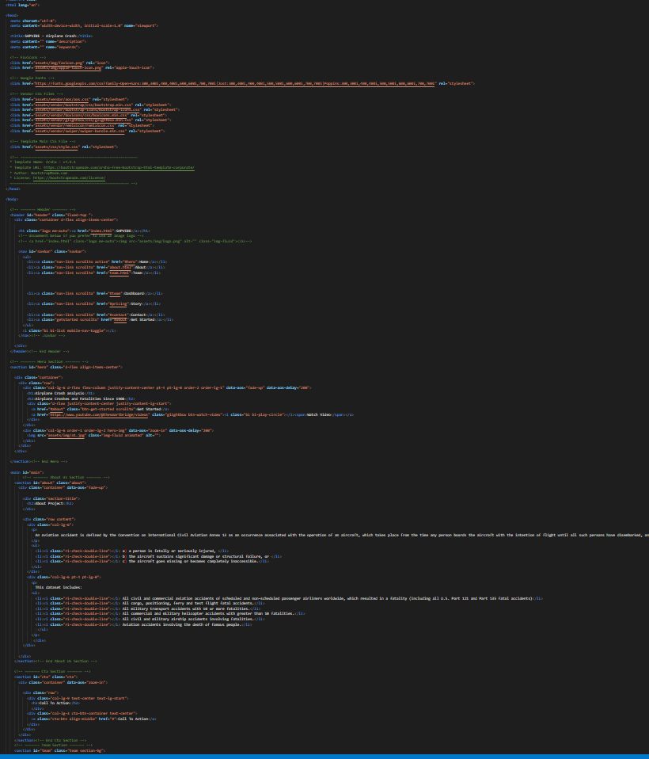

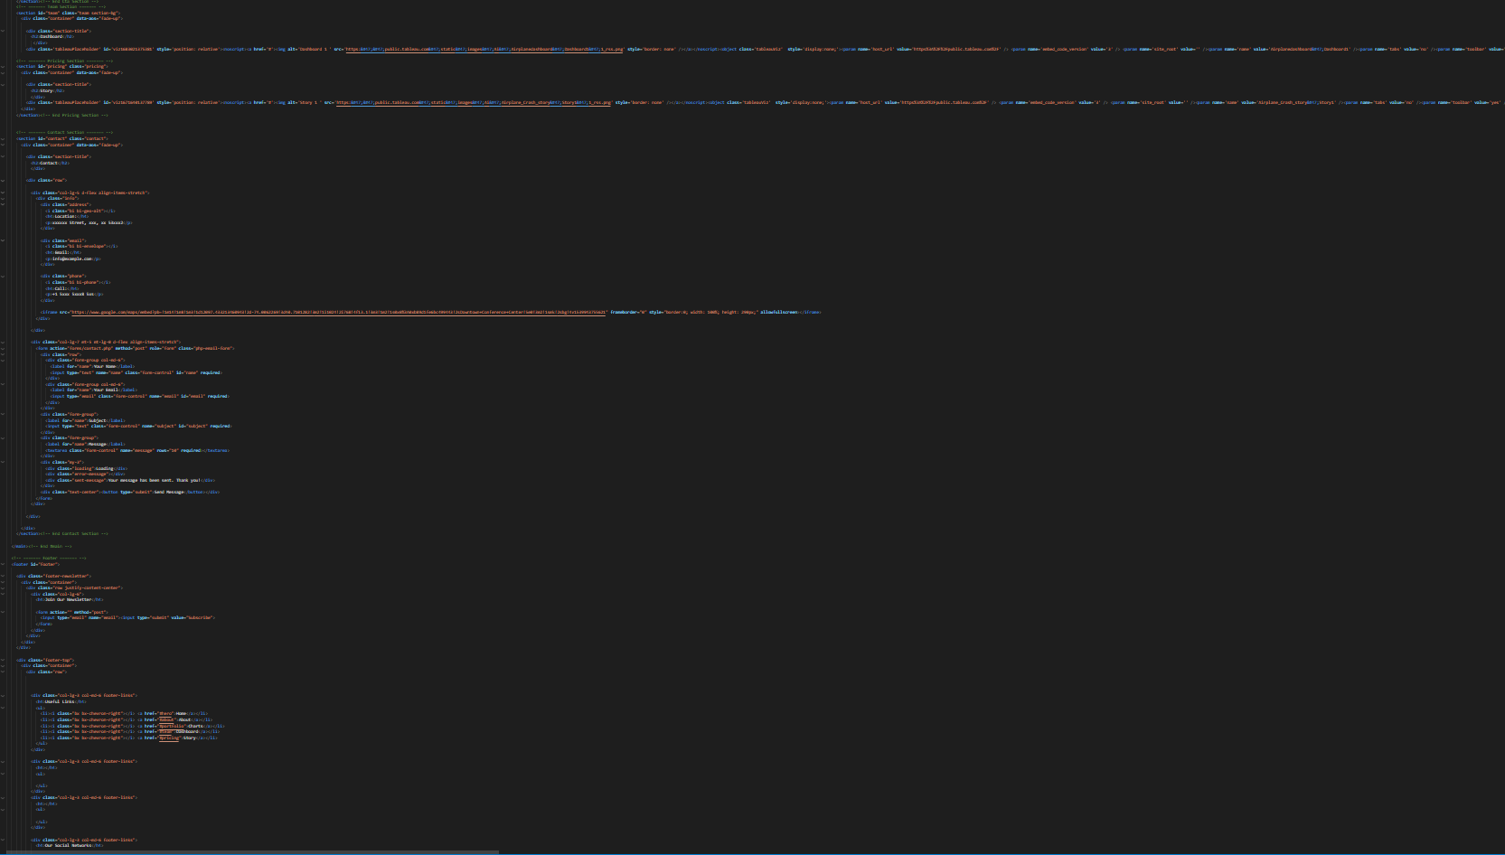

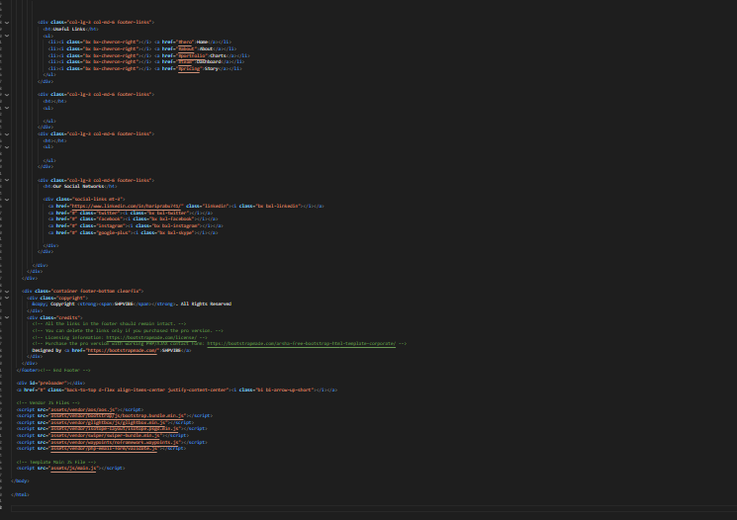

**SOURCE FOLDER LINK:**

[**https://drive.google.com/drive/folders/11qT-iSTcCSSRZH-ahK-yg45_DQcuL7XB?usp=share_link**](https://drive.google.com/drive/folders/11qT-iSTcCSSRZH-ahK-yg45_DQcuL7XB?usp=share_link)

**SOURCE CODE LINK:**

[**https://drive.google.com/file/d/1MXHEFPupt9ZAba2J9TuWD88hwvmqKz3g/view?usp=share_link**](https://drive.google.com/file/d/1MXHEFPupt9ZAba2J9TuWD88hwvmqKz3g/view?usp=share_link)

**VIDEO LINK:**

[**https://drive.google.com/file/d/1hDmoHH5tOirc_suq6NJbYPEiDsGZfyzt/view?usp=share_link**](https://drive.google.com/file/d/1hDmoHH5tOirc_suq6NJbYPEiDsGZfyzt/view?usp=share_link)

**TABLEAU PUBLIC:**

**Story:**

[**https://public.tableau.com/views/AirplaneStory/Story1?:language=en-US&:display_count=n&:origin=viz_share_link**](https://public.tableau.com/views/AirplaneStory/Story1?:language=en-US&:display_count=n&:origin=viz_share_link)

**Dashboard:**

[**https://public.tableau.com/views/Airplanedashboard/Dashboard1?:language=en-US&:display_count=n&:origin=viz_share_link**](https://public.tableau.com/views/Airplanedashboard/Dashboard1?:language=en-US&:display_count=n&:origin=viz_share_link)